USER MANUAL - CODRUG

- DESCRIPTION:
This is a tool applied to QSAR analysis using machine learning (ML) models. Its design includes everything from the preparation of labeled internal datasets, preprocessing, exploratory and statistical analysis, generation of molecular descriptors and feature engineering, construction and validation of regression models, classification and clustering, cross-validation, hyperparameter optimization, and prediction of classes or bioactivities in external databases. This interface guides users through complex processes, reducing the need for programming knowledge and IDE use. It was developed in Python 3.10.12 using the PyQt5/Qt 5.15.14 framework, with an intuitive and modular graphical interface organized into sequential tabs. The main libraries integrated into this tool were ChEMBL Web Client, Pandas, Numpy, Matplotlib, RDKit, PaDEL-Descriptor, TensorFlow, PyTorch, Pycaret, and Scikitlearn.

- INSTALLATION:
2.1 Download the compressed file from the link:
https://github.com/moimaian/CODRUG/archive/refs/heads/main.zip

2.2 Extract the file to a working folder, for example, "$HOME/CODRUG":
This can be done graphically in a file manager such as Nemo
- Extract the contents of the CODRUG-main.zip file to your system's home folder, creating the folder $HOME/CODRUG (remove -main from the name)
It is also possible to extract and rename the folder by opening a terminal window in the Downloads folder and executing the commands:
sudo apt-get install unzip # If you have not installed
unzip CODRUG-main.zip
mv $HOME/Downloads/CODRUG-main $HOME/CODRUG

2.3 Still in the terminal, run the CODRUG.py file using the command:
cd $HOME/CODRUG && python3 ./CODRUG.py

Use the following command if you do not have python3 on your system:
sudo apt update
sudo apt install python3 -y

A window will then appear describing the requirements that are not installed in the environment so that the user knows what needs to be installed beforehand. This installation can be done through the interface itself, which will open automatically, or with the module_requirements.py file in the MODULES folder.
In this first run, the Python virtual environment will be created in $HOME/.venv/CODRUG, where the program packages that are dependencies for running CODRUG will be installed (see topic 3).
For installations via the terminal, this environment can be activated with the command:
source $HOME/.venv/CODRUG/bin/activate

- PREREQUISITES:
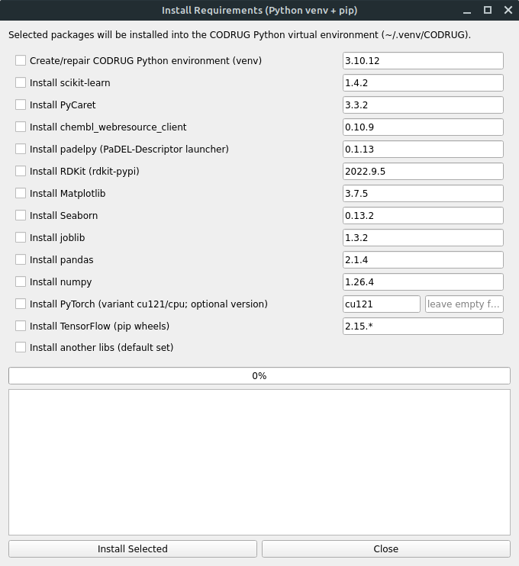
On the first startup, either automatically or through the HOME tab in the interface, you can open the prerequisite installation window. In the case of the HOME tab (Figure 1), there is an Install requirements option at the bottom that, when clicked, takes you to this installation window (Figure 2), where the prerequisites for running CODRUG and their versions will be listed. This is a list with checkboxes that allow the user to choose which programs they want to install and their versions. If this is your first time running the program, check all options. The proposed versions have been tested and are compatible with each other; however, if the user wishes, they can change to more recent versions. It is important to be careful when changing the versions of a package, as you need to make sure that it is compatible with the others. The predefined versions have already been tested and do not present any conflicts.
Figure 2. Configuration tab.

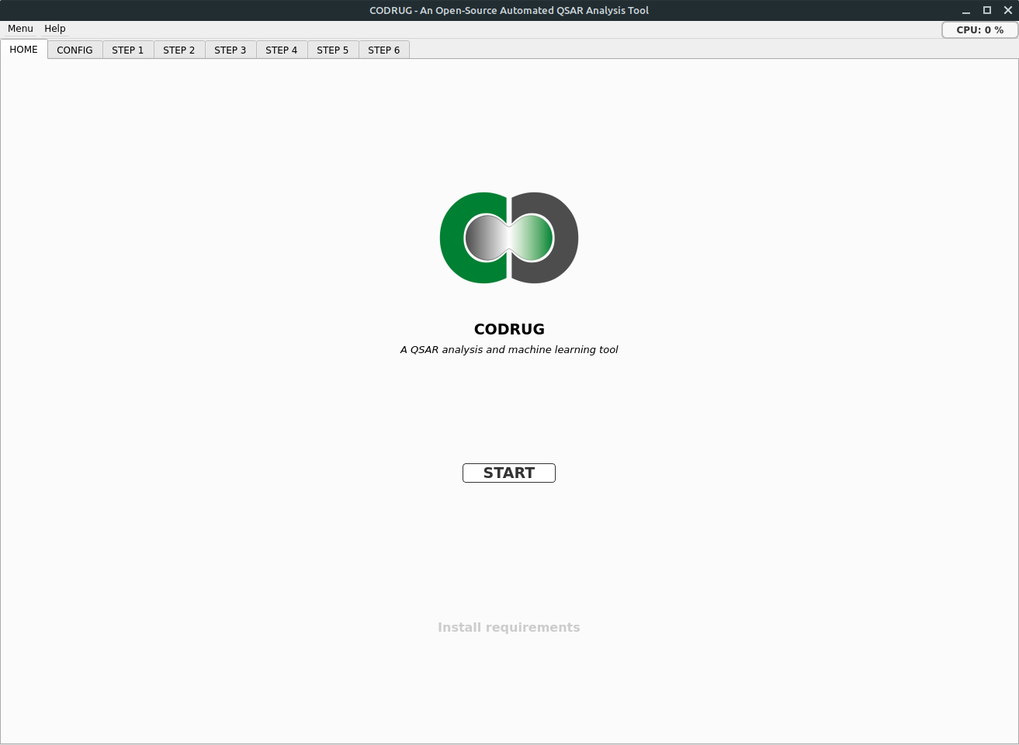

Figure 1. CODRUG HOME window.
- DIRECTORY ORGANIZATION:
During the CODRUG startup process, the necessary directories are checked. If these directories are missing, they will be created in the folder where the CODRUG.py executable file is located. The organization of directories and subdirectories is described in Figure 3 below, with some illustrative examples. It is worth noting that the USI is an identification code generated by Pycaret for each training/testing setup, making it possible to test various combinations of methods for scaling, selecting, or projecting data within the same project/job.
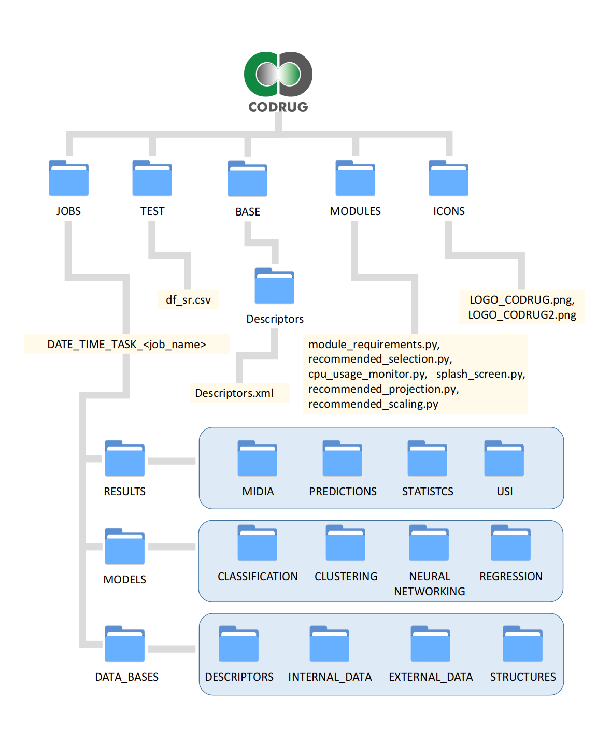

Figure 3. Directory organization.

- GENERAL USAGE GUIDELINES:
After the home tab, the user must enter the project settings tab and select the type of task to be performed: Classification, Regression, Clustering. A new project must be created or a previous existing project must be resumed. Clicking the Set Run Folder button creates the necessary folders and subfolders (Figure 4).
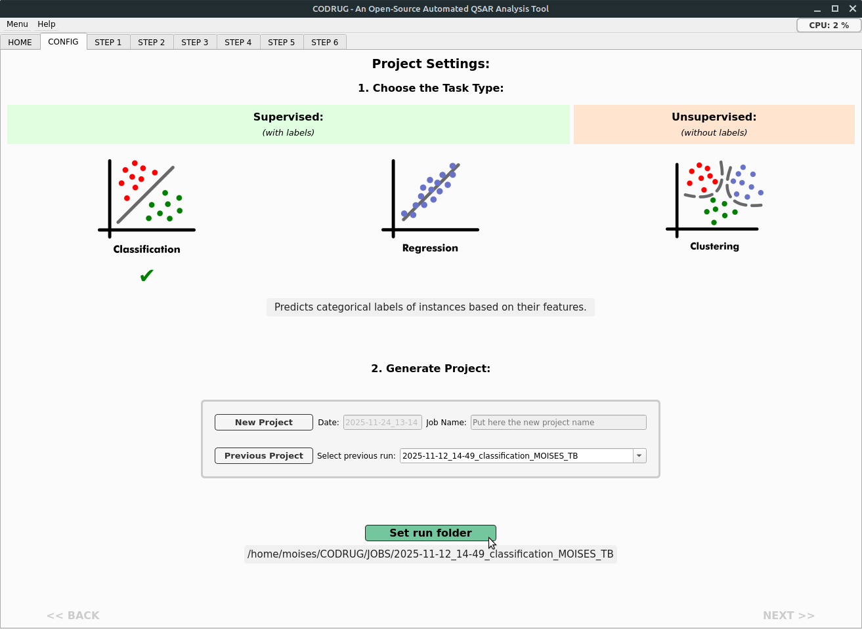

Figure 4. Configuration tab.

Step 1 - Database preparation: In this step, the ChEMBL Web Client API is used to access the ChEMBL database. Several tools for searching and filtering data are available (Figure 5). The search begins by selecting the Target Type (Organism, Single protein, Protein Complex, Cell-Line), Organism Name, Pref. Name, and Target ChEMBL ID. When you fill in the name of the organism and click Explore by target, a new window with a dataset will open. From there, you can select the Target ChEMBL ID according to the value of num_compounds_tested. Only the Pref. name is not mandatory, and thus, with the other fields filled in, clicking on Generate Dataset by activity will generate the complete dataframe, saved in .csv format in the folder ~/CODRUG/JOBS/DATE_TIME_TASK_<JOB_NAME>/DATA_BASES/INTERNAL_DATA with the name df1_by_activity_<Target ChEMBL ID>_<Organism_name>.csv. This dataframe will serve as the basis for subsequent filtering with local access, avoiding repeated and time-consuming requests to the online database (Figure 5). For tasks involving cell line data, it is important to use the Explore by cell-line feature, filling in the fields cell_chembl_id, cell_name, cell_source_tissue, and cell_description to obtain the most appropriate base dataframe. This information can be found in advance on the web portal https://www.ebi.ac.uk/chembl/ . Using the tools available in View frequency graph, it is possible to explore the data in each column, evaluating, for example, the Assay Type or Unit, thus allowing the most frequent options to be chosen (Figure 6).

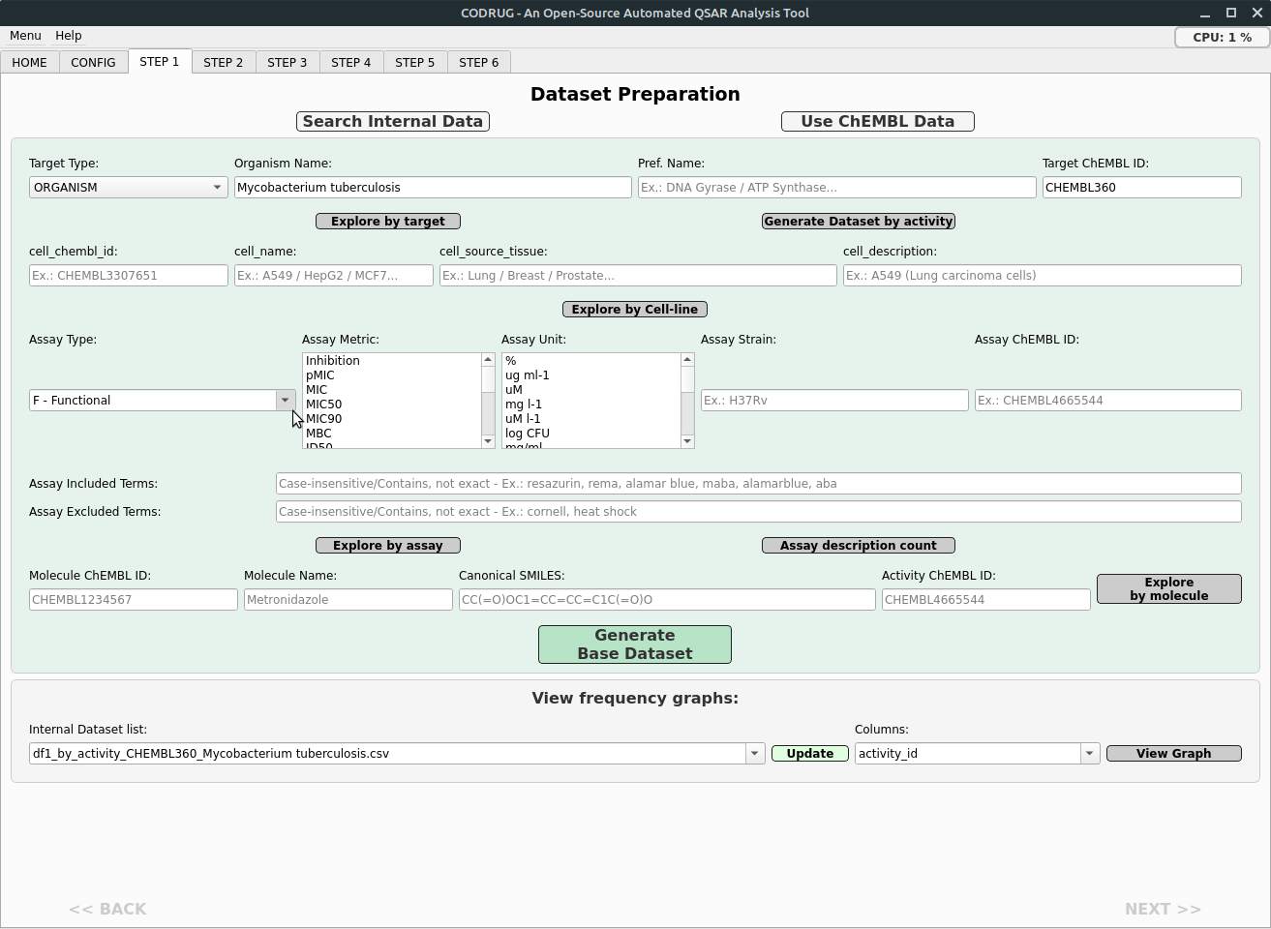

Figure 5. Window for step 1 of dataset preparation.

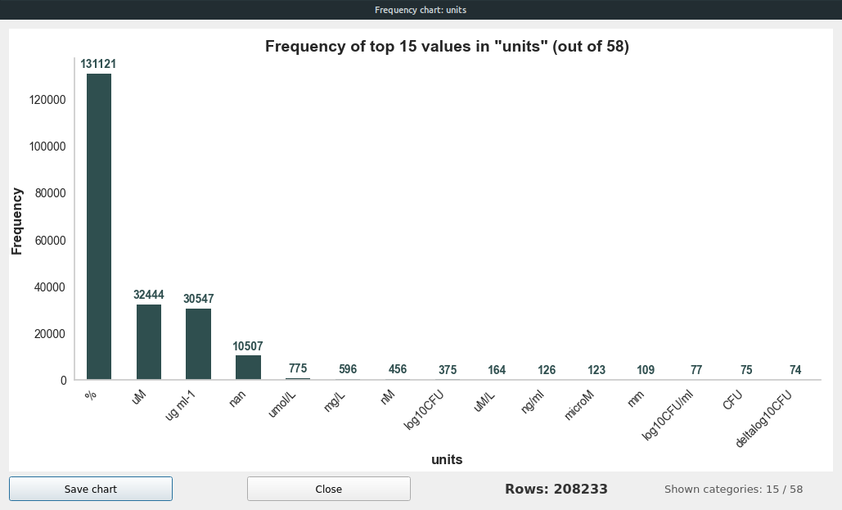

Figure 6. Distribution of data according to the type of unit of measurement.

The type of assay can be chosen from: Functional (F), Binding (B), Pharmacokinetics (A), Toxicity (T), or Unsigned (U). By clicking on the Assay description count button, it is possible to check the different descriptions of the assays and their frequency in the dataframe, in addition to updating the lists of options in Assay Metric and Assay Unit. Multiple units can be chosen as long as they can be converted between each other based on the molar mass of the compounds. The interconvertible concentration units are: M, mM, uM, nM, mol/L, moll-1, mmol/L, mmoll-1, umol, umol/L, umoll-1, µmol, µmol/L, μmol, μmol/L, nmol, nmol/L, nmoll-1, ng/uL, ng/mL, ng/L, ug/uL, ug/mL, ug/L, mg/uL, mg/mL, mg/L, g/uL, g/mL, g/L. And also the dose/weight units: ng/g, ug/g, mg/g, g/g, ng/kg, ug/kg, mg/kg, g/kg. In order to keep only trials of a similar nature in the dataframe, so that their bioactivity values can present a pattern that correlates with features, it is necessary to define inclusion and exclusion terms. Filling in the Assay Included Terms and Assay Excluded Terms fields will then depend on careful curation of terms present in the assay_description column. If you consider the description obtained through the Assay description count button insufficient, you can make a new request to the ChEMBL Web Client using the Explore by Assay button, which will provide a different description in the description column, allowing the selection of other terms.
With the Target Type, Organism Name, Target ChEMBL ID, Assay Type, Assay Metric, and Assay Unit fields filled in, it will be possible to generate the base dataframe df2_base_<Target ChEMBL ID>_<Organism_name>.csv in the INTERNAL_DATA folder. Based on the Molecule ChEMBL ID or Canonical SMILES, it is possible to search for specific information about a given compound. The lower part allows you to generate bar graphs with the relative frequencies for a given column. The update button allows you to update the dataframe options in the INTERNAL_DATA folder for the internal data list combobox. When you select the dataframe from this list, the Columns combobox will be updated, and then you just need to choose the column and click the View Graph button to view it (Figure 6).

Step 2 - Preprocessing and exploratory analysis: In this step, the following preprocessing tasks are performed: Selection of columns of interest in the base dataframe, removal of instances with empty or null values, conversion of units, treatment of repetitions, normalization/transformation of bioactivity values, and removal of outliers. At the end of each block, if the dataframe selection option does not open automatically, it is important to select the last dataframe generated with the SelectDataFrame button (Figure 7).
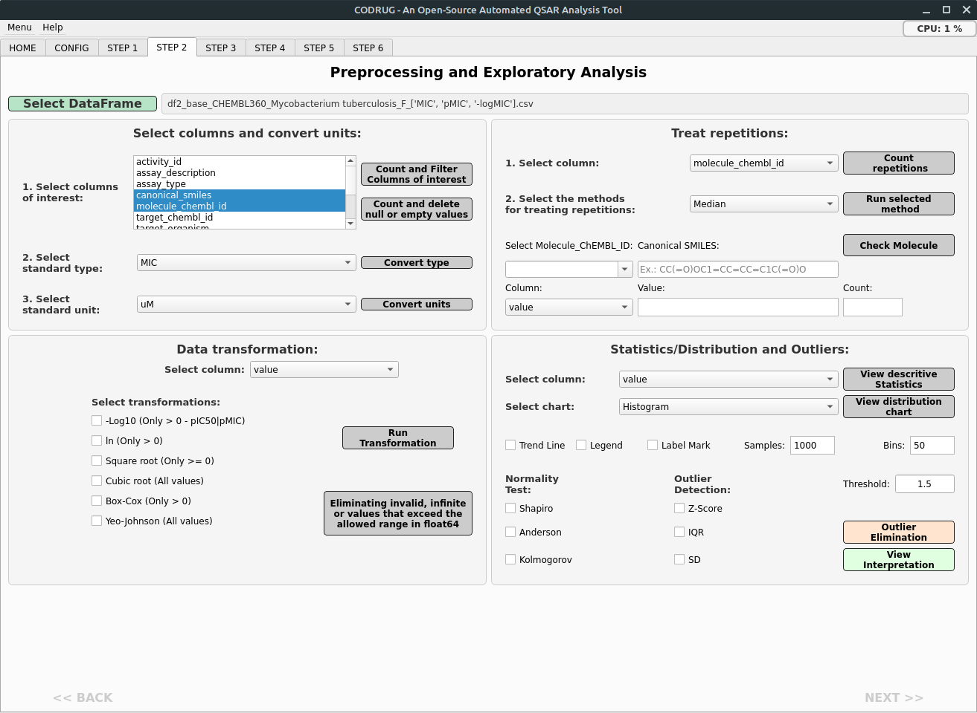

Figure 7. Window for step 2 of Preprocessing and Exploratory Analysis.
Step 3 - Preprocessing and Statistical Analysis: In this step, the data can be categorized as Active, Intermediate, and Inactive according to their Bioactivity values (MIC, IC50...) considering the first quartile (Active if less than or equal) and the third quartile (Inactive if greater) as reference values. Next, we can generate columns with Lipinski's properties (Set Lipinski Descriptors) and filter the compounds into specific value ranges according to the rules of drugability (Filter by Lipinski's Rule). As mentioned earlier, at the end of each block, it is important to select the last dataframe generated with the SelectDataFrame button. This will display the classes in the Select groups multiple selection box. There are two types of statistical analyses: for class comparison and for variable correlation. In the first, it is necessary to evaluate the assumptions of normality and homoscedasticity by selecting the comparison variable in Select Variable and clicking the Verify Assumptions button (Figure 8).
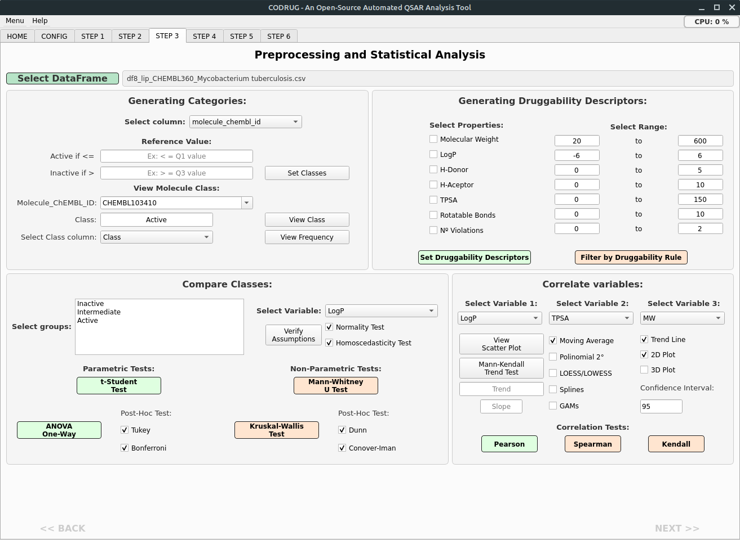

Figure 8. Window for step 3 of Preprocessing and Exploratory Analysis.

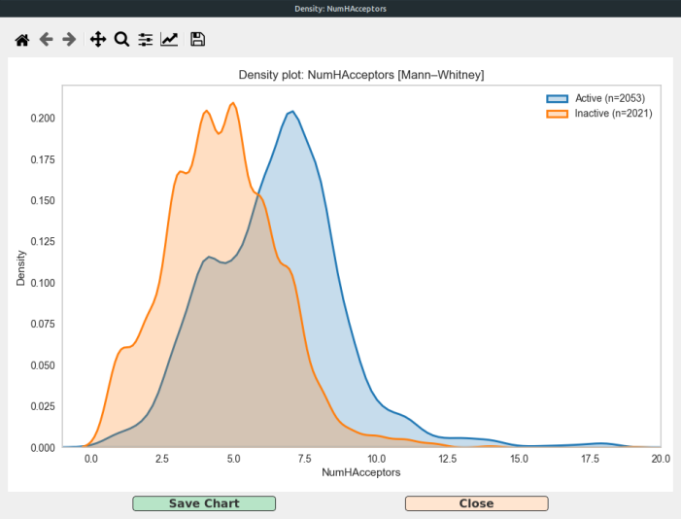
In select groups, if only two classes (Active and Inactive) have been chosen, the One-Way ANOVA and Kruskal-Wallis Test analyses will be disabled (used for three or more groups). If the selected variable does not show normality and homoscedasticity, the nonparametric Mann-Whitney U Test should be used instead of the Student's t-Test. Clicking on the class comparison method button will generate a text window with the interpretation of the results and, at the end, a density graph (Figure 9).

Figure 9. Density graph visualization window for class comparison.

To understand how correlated the variables are and how much the association between them is able to differentiate the groups (Active and Inactive), we can select a new dataframe in Select DataFrame. Then we choose the variables. The Pearson (parametric) and Spearman and Kendall (non-parametric) correlation tests will evaluate the variables selected in Select Variable 1 and Select Variable 2, generating an interpretation window and then the linear curve graph with confidence interval. Different types of trend lines can be plotted (moving average, 2nd degree polynomial, LOESS/LOWESS, splines, and GAMs). The Mann-Kendall Trend Test button will provide the type of trend (whether monotonically positive or negative) and the Slope value in the boxes below (This gives an idea of how much the value of variable 1 is changing per unit of variable 2, i.e., the slope of the linear correlation curve). Clicking the View Scatter Plot button will generate a 2D or 3D graph according to the option selected in the corresponding checkbox (Figure 10).

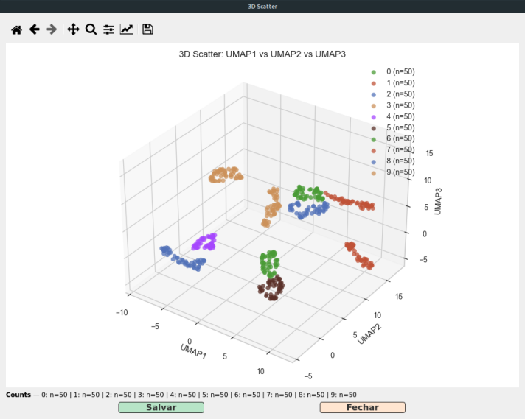
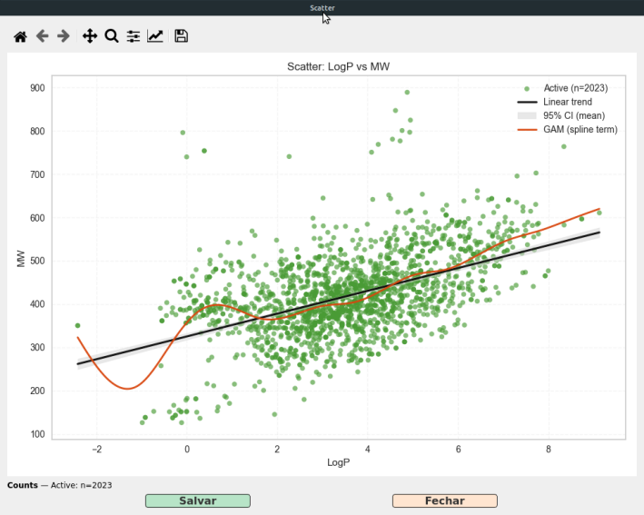

Figure 10. Windows with 2D and 3D Scatter Plot graphs for comparing variables and differentiating classes.

Step 4 - Feature engineering: In this step, the main descriptors that will compose the set of predictor variables (X values) will be generated and treatments for dimensionality reduction will be applied. In Descriptors builder, the checkbox for the type of descriptor (1D/2D, 3D, and Fingerprint) to be listed in Select Descriptors must be checked. More than one descriptor type can be chosen from the list. Next, select the column containing the structural information (canonical smiles) that will be used to generate the descriptors, the column corresponding to the response variable (MIC, IC50, Potency, etc.), and the column that identifies each compound (such as molecule_chembl_id). Other processes that can be selected in the checkbox before generating the descriptors are: Removal of salts, detection of aromaticity, standardization of tautomers, standardization of nitro groups, maintenance of 3D coordinates (if the structures are already in 3D format) or Conversion to 3D, if the structures do not have 3D coordinates and a 3D descriptor has been selected (Figure 11).
Descriptors can be calculated directly by clicking the Generate Descriptors button or by opening the PaDEL-Descriptor interface by clicking the Open-GUI PaDEL-Descriptor button. To reduce dimensionality, select: bioactivity column, class column (used only if the task type selected in the CONFIG tab is classification), and the range of indices corresponding to the descriptors. When you click Select DataFrame to choose the dataframe containing the descriptors that were recently calculated, the program automatically adds the names of the corresponding columns. It is always important to check that the index range in Features Columns Range actually corresponds only to the descriptors, considering that the first column has index 0 and thus the index of the last column corresponds to the total number of columns minus one. From then on, the scaling, selection, and projection processes can be selected and applied. However, if you want the program to recommend the most appropriate options for the nature of your descriptors, you can also define the Feature Type (continuous, binary, categorical, or ordinal), Attribute Option (with noise/outliers, sparse, dense, low cardinality, high cardinality, high correlation, or non-linear correlation), and the Model Type, which defines the type of AI model you want to apply to the data (tree, linear, distance, probabilistic, neural network, or clustering).
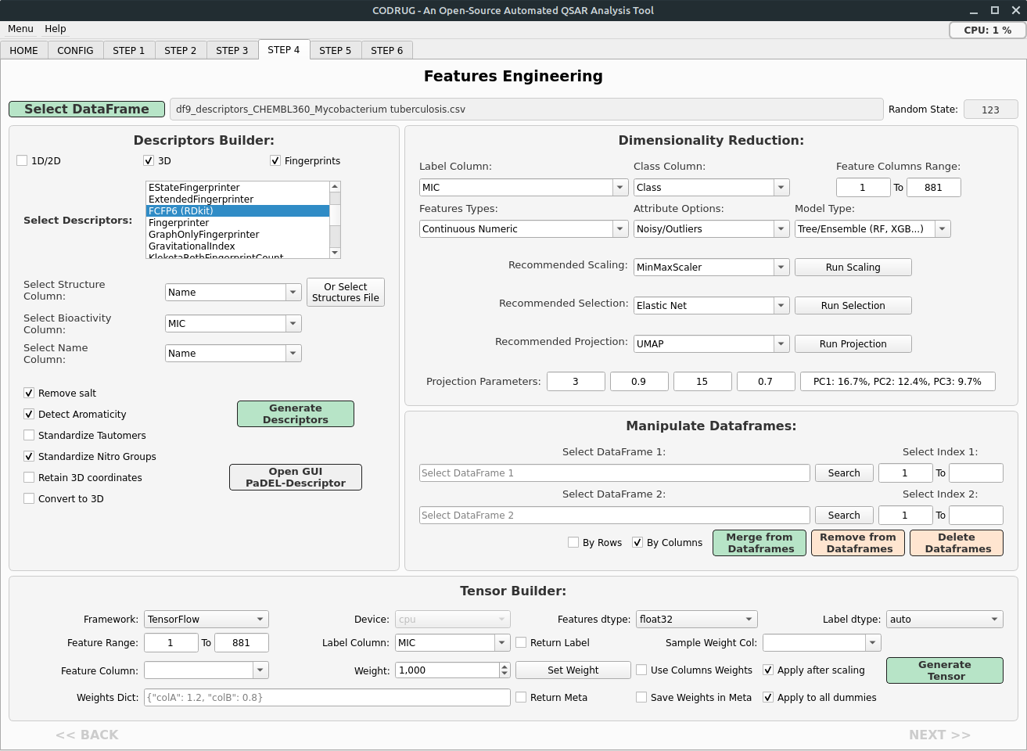

Figure 11. Window for step 4 of feature engineering and dimensionality reduction.

In the Manipulate Dataframes section, we can make some adjustments by merging or removing columns or rows between dataframes or even deleting the dataframe completely. In the Tensor Builder section, it is possible to generate a one-dimensional vector that can be used as input for artificial neural networks (ANN). These models will be implemented later.

Step 5 - Similarity and Applicability Domain Analysis: In this step, we must select the internal dataframe by clicking Select Internal DataFrame. This dataframe must be the same one used for training and testing the ML models, but containing only the names column and the descriptor columns, i.e., without the Bioactivity and Class columns. Similarly, the external dataset, i.e., the set of compounds to which the ML model will be applied to predict the response variable (Bioactivity), must be selected by clicking Select External DataFrame (Figure 12). These two dataframes can be prepared and adjusted in the previous step using the Manipulate Dataframes session. The parameters k (for KNN), α, and Fingerprint are already predefined. Clicking on Compute AD will generate a table containing the results of leverage, knn, Mahalanobis, and Tanimoto, ultimately generating a score and a verdict: Within AD, Borderline, Outside AD (Figure 13).

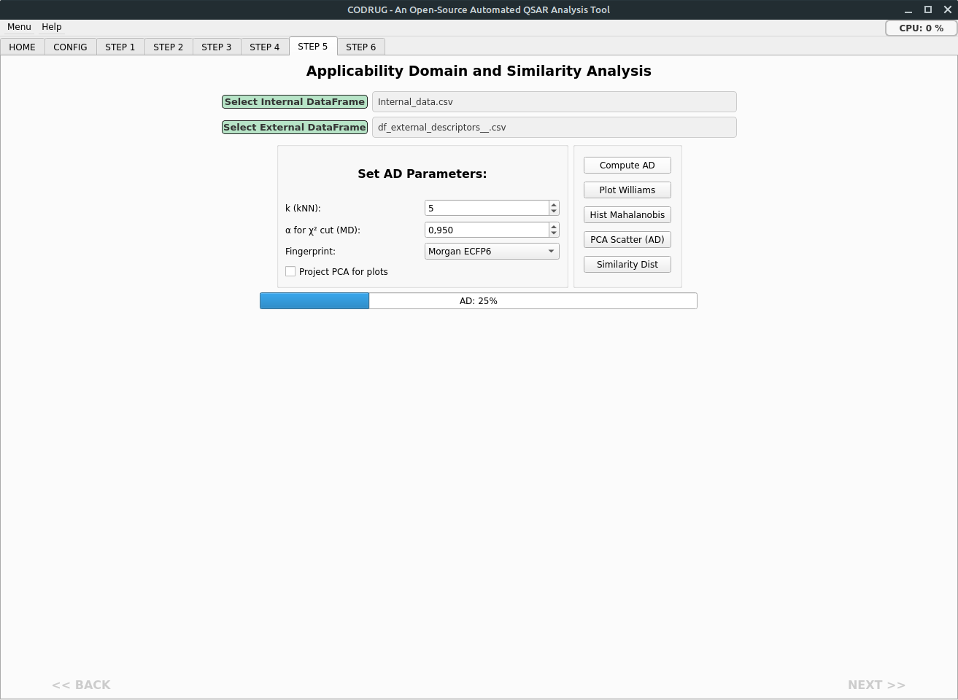

Figure 12. Window for step 5 of Similarity and Applicability Domain Analysis (AD).

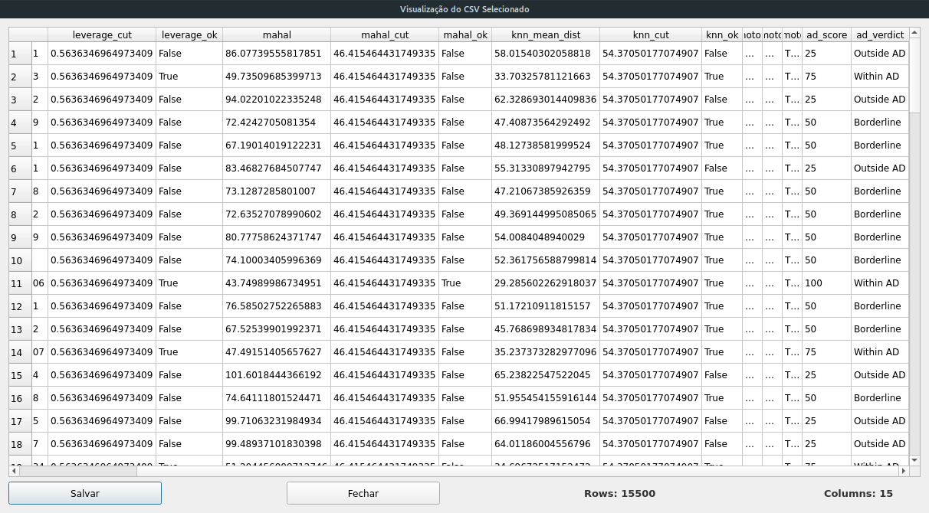

Figure 13. Window of step 5 of Compute AD results.

Step 6 - Machine Learning Models: Screening and application. In this step, the models will be screened and ranked according to the chosen performance metric. The best model can be saved and used for application in an external dataframe containing the same descriptors. First, we must choose the internal dataframe that will be used to rank the models by clicking the Select Internal DataFrame button and leaving the Internal Dataframe checkbox enabled. The External Dataframe checkbox will only be checked when we use the Load button to load a saved model and thus apply it to the external dataframe (Figure 14).
In the vertical Setup tab, under Set Setup Parameters, the column corresponding to the response variable must be selected (Select Y Column). The other parameters can be enabled and adjusted or left unchecked so that they are applied automatically. The ignore_features checkbox must be checked and the columns that will be ignored for the model must be described, such as Name and Class (if it is a regression model) or the Bioactivity column (if it is a classification model). Click the Setup button to generate the parameter table and the USI screening identifier code that will be used to name the results folder.
In the vertical Compare tab, check the sort checkbox to define the metric that will be used to rank the models (usually R2 for regression and Accuracy for classification). If you do not want this first screening to take too long, you can check the exclude model box and describe the model with the longest training time (lightgbm). Click the Compare button and wait for the progress bar until the dataframe with the ranked models and their metrics is generated. In Evaluate, the Use_gpu checkbox can be checked so that validation is performed using the GPU, speeding up the process. In Tuning, check the Metric optimization option and select the metric under which the model will be optimized with hyperparameter adjustment.

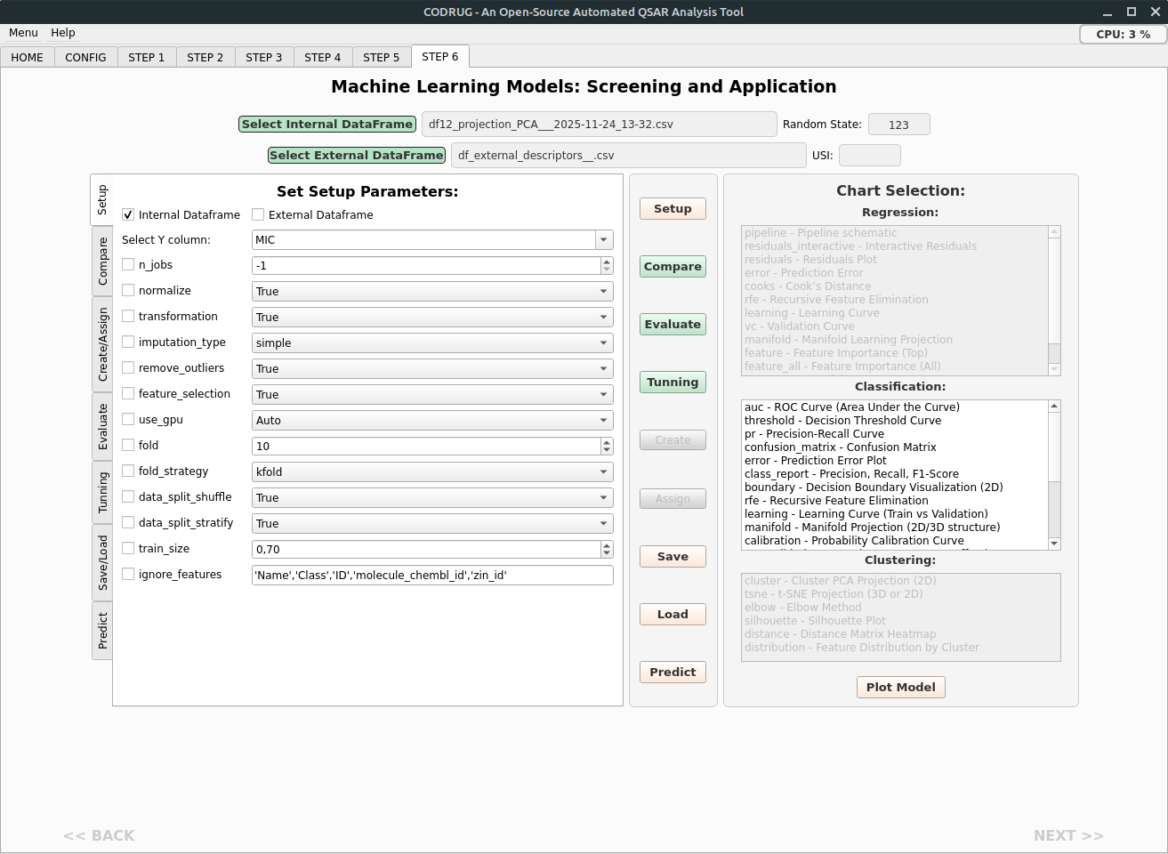

Figure 14. Window for step 6 of Screening and application of machine learning models.

After tuning, the best model can be saved in the ~/CODRUG/JOBS/DATE_TIME_TASK_<JOB_NAME>/MODELS folder in .pkl format by clicking the Save button. This .pkl model can be loaded later by clicking the load button and applied to the prediction of bioactivity values for an external or class dataframe. To do this, you must first click on Select External DataFrame, check the External dataframe checkbox in Set Setup Parameters, redefine the select Y Column, and ignore_features, if necessary, and execute the setup button. Only then can the load be performed and the predict button be used to generate a new column of predictions of Y values based on X values (Descriptors). Depending on the type of task selected, the Chart Selection list will be enabled or disabled. After setup, comparison, and tuning, you can generate training, testing, and validation graphs for the best model. They can be selected in the respective selection box and generated by clicking the Plot Model button. These selected graphs will be saved in the folder ~/CODRUG/JOBS/DATE_TIME_TASK_<JOB_NAME>/RESULTS/USI/<USI code>/MIDIA. Some examples are shown in Figures 15 to 20 below.
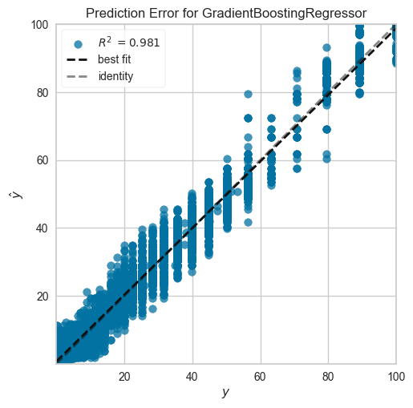
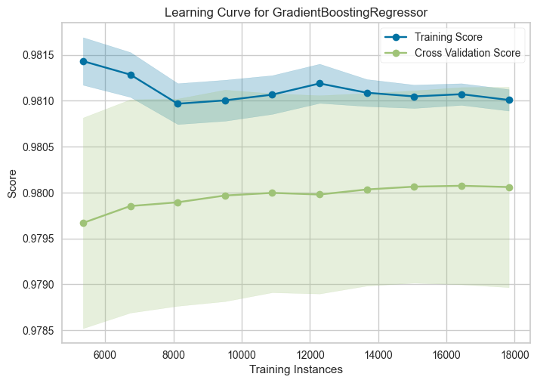

Figure 16. Learning Curve graph in a Regression task.
Figure 15. Prediction error graph in a Regression task.

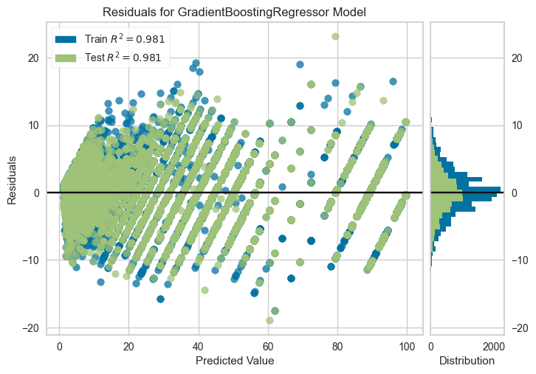

Figure 17. Residual graph in a regression task.
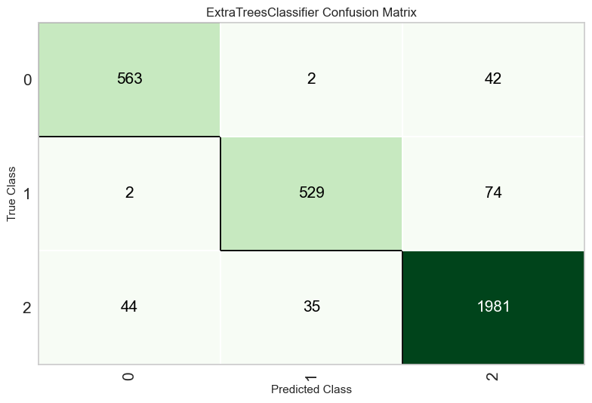
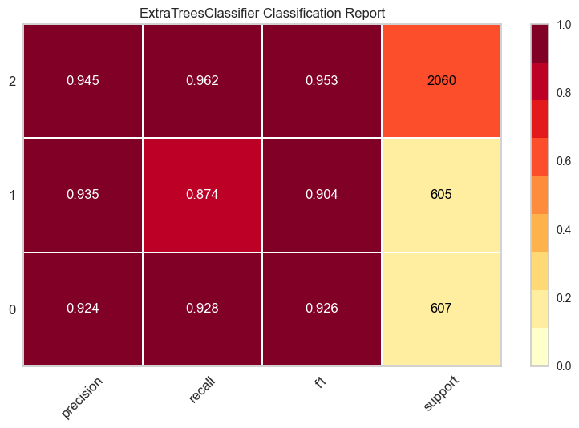

Figure 18. Confusion Matrix graph in a Classification task.
Figure 19. Classification report.
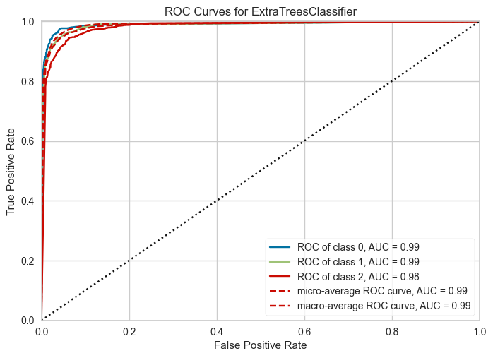

Figure 19. Area Under the Curve (AUC) graph in a Classification task.

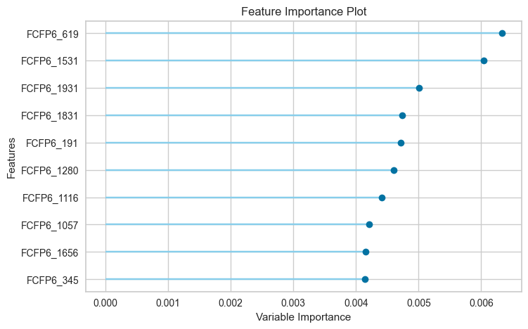

Figure 20. Feature Importance graph in a Classification task.

